Practical DevOps– Assignment on AWS

Use Terraform to provision VPC, EC2, ECR and EKS on AWS
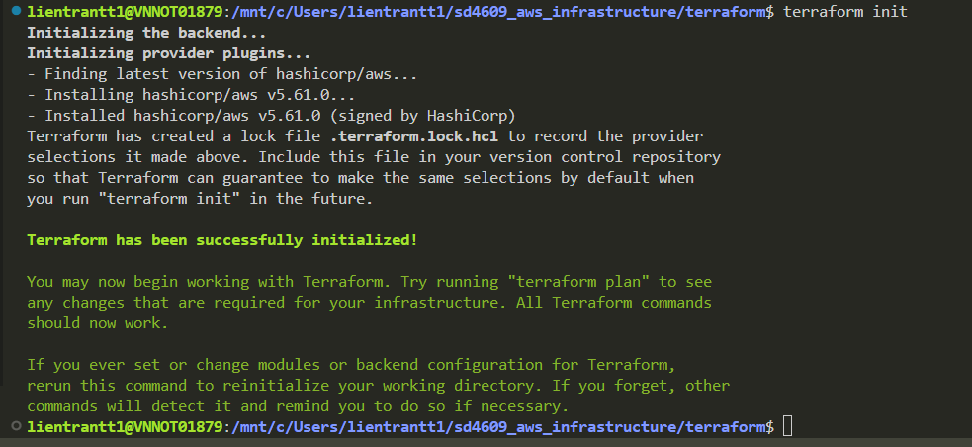
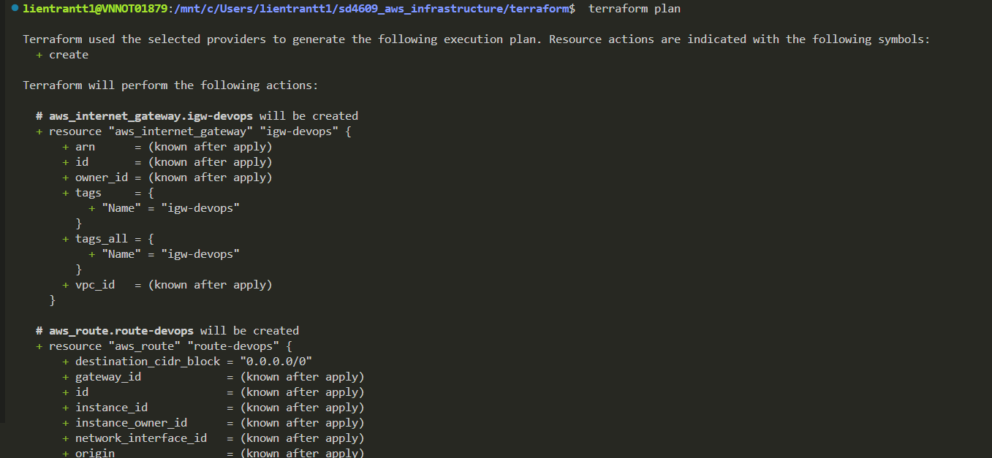
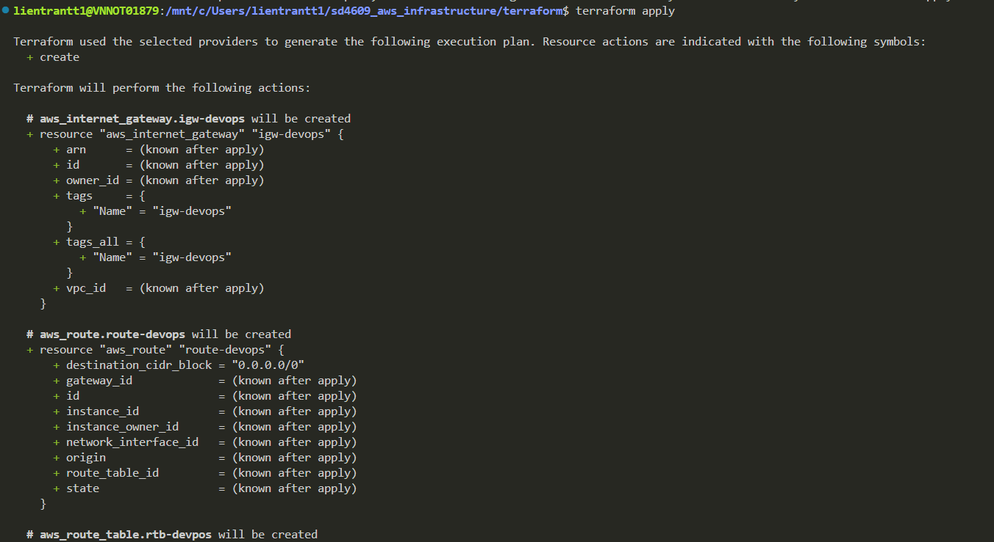

- VPC
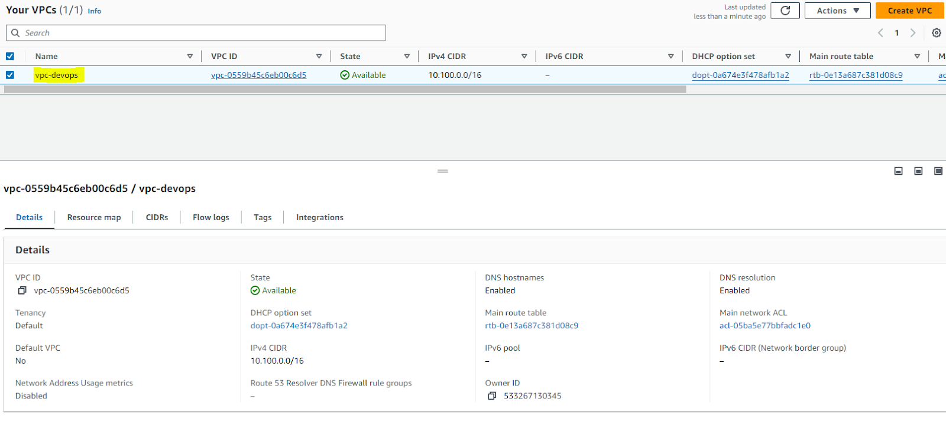
- EC2
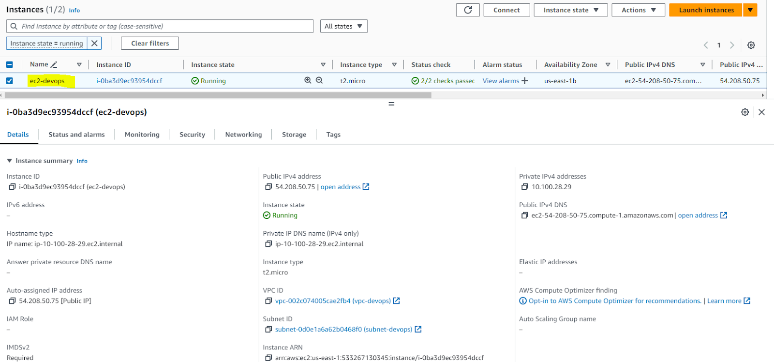

- EKS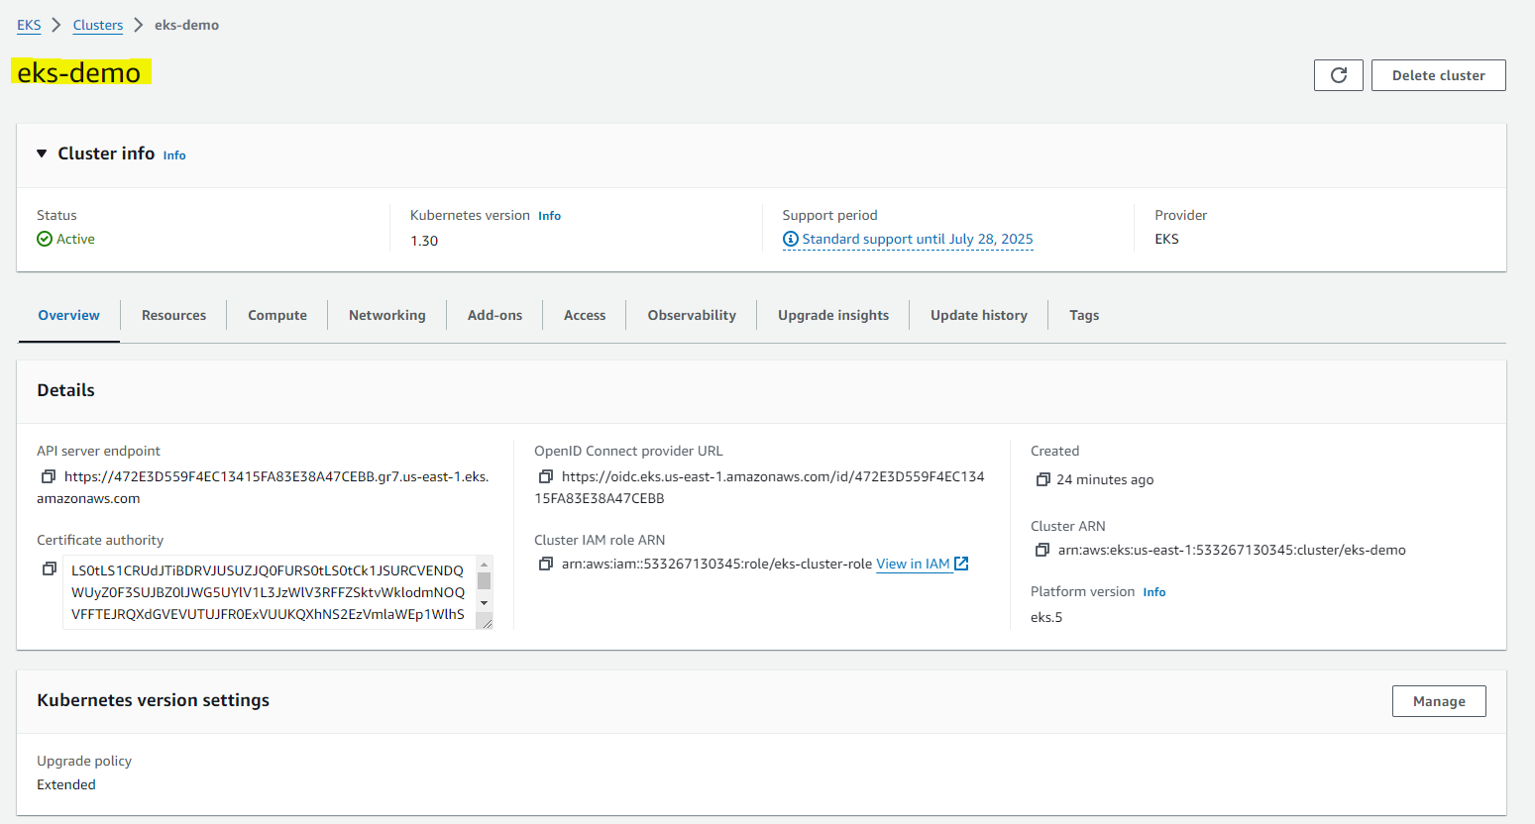
- ECR
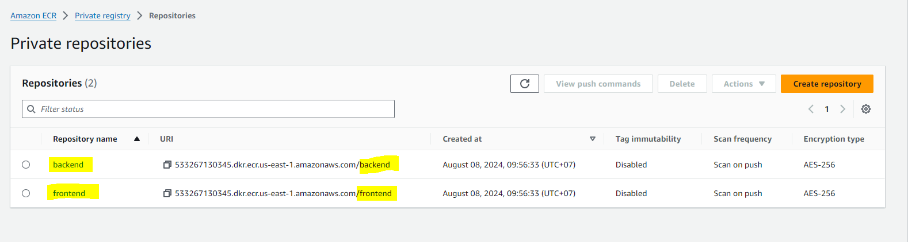

- Setup Jenkins pipeline for CI/CD
Github link:
https://github.com/thuylien87/backend
https://github.com/thuylien87/frontend

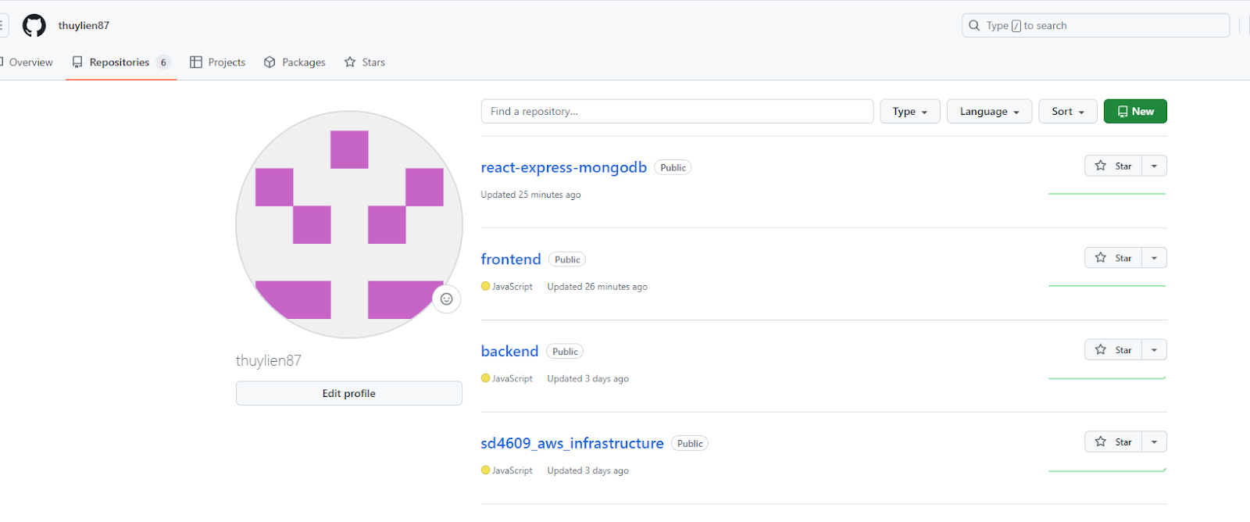

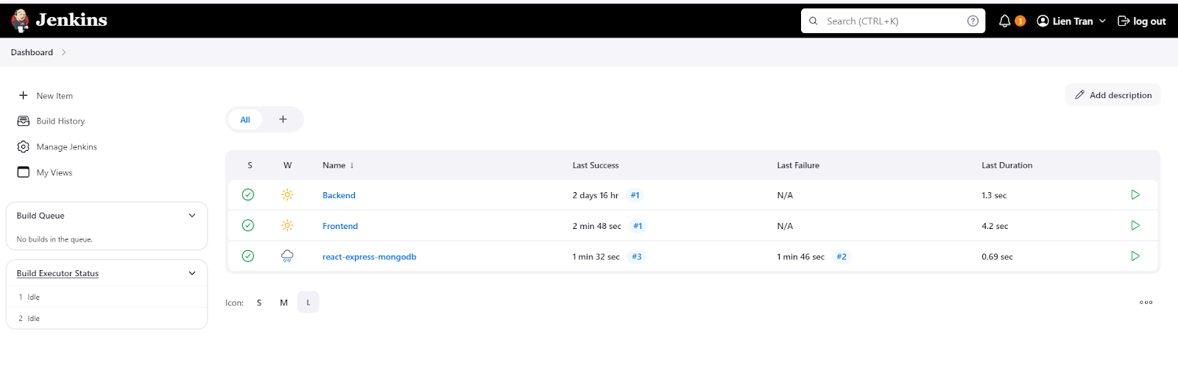
5. Monitoring Set up Prometheus and Grafana to monitor EKS resources and default EKS resource metric.
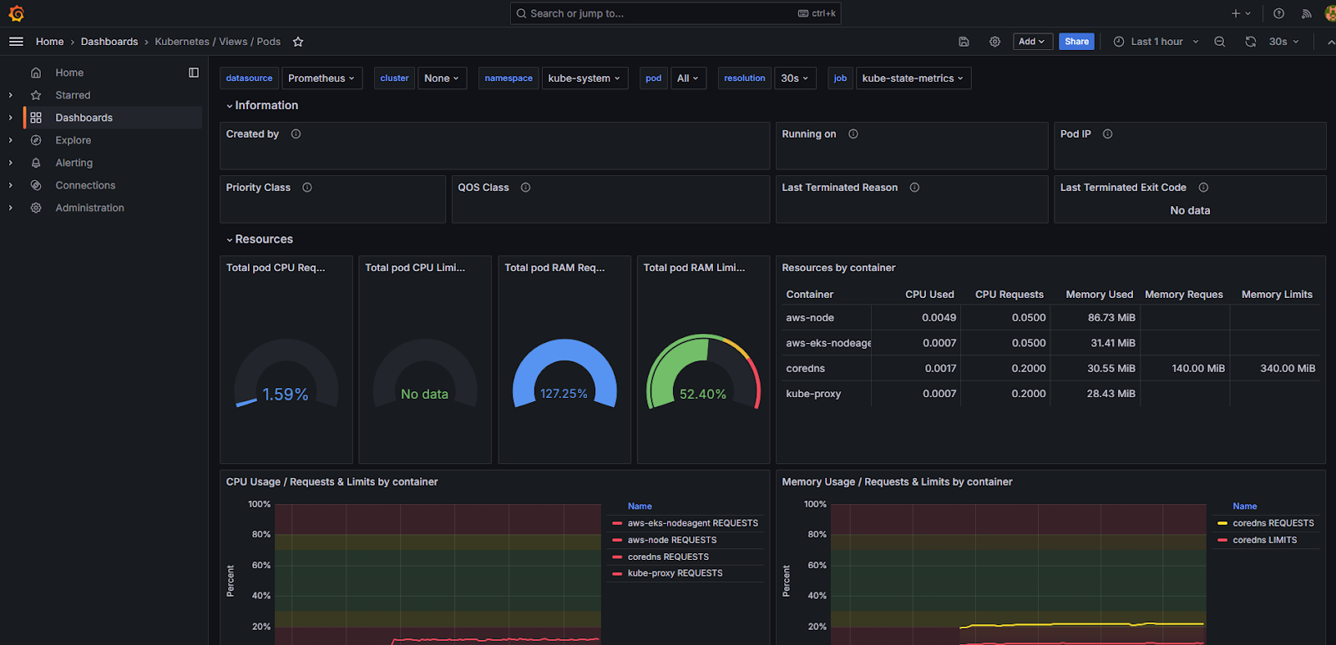

- Reuse Jenkins CI and use GitOps for the CD pipeline.
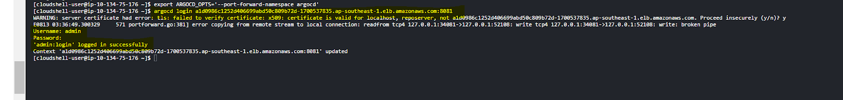

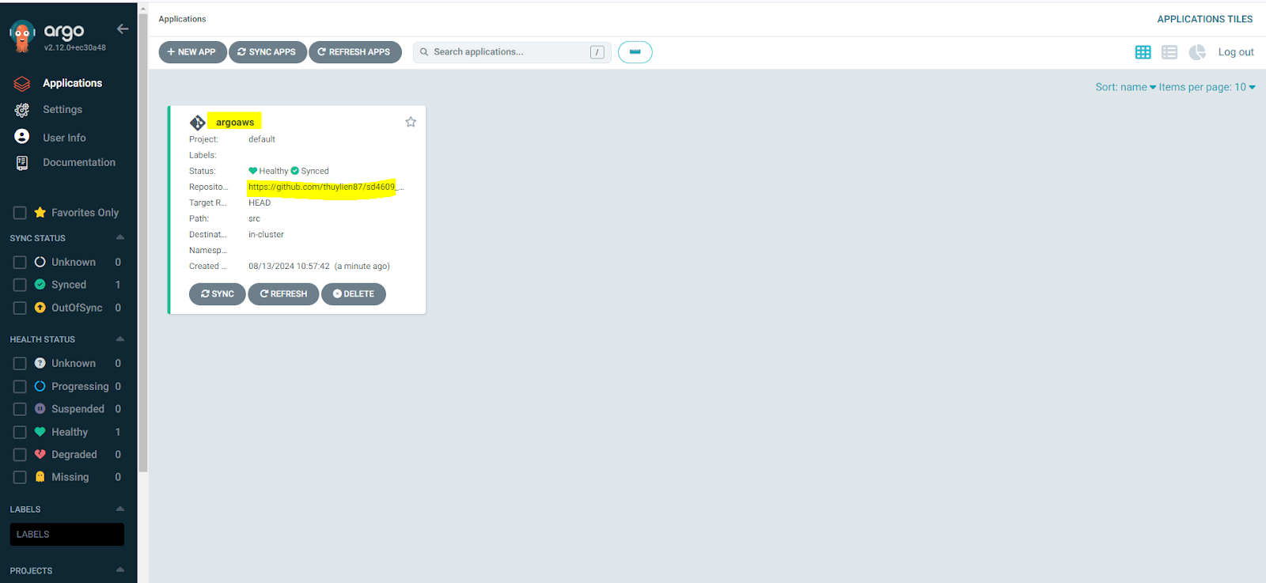

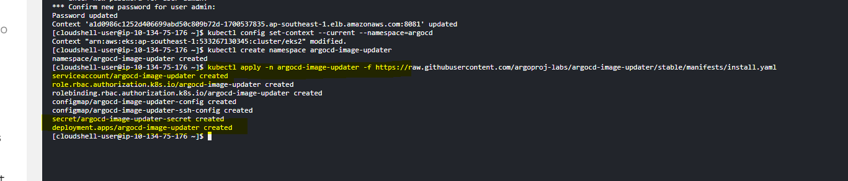

AZURE
- Use Terraform to provision Azure Virtual Network, ACR and AKS on Azure.
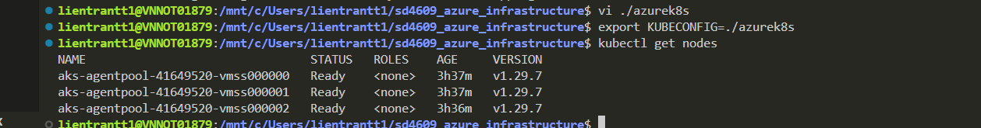

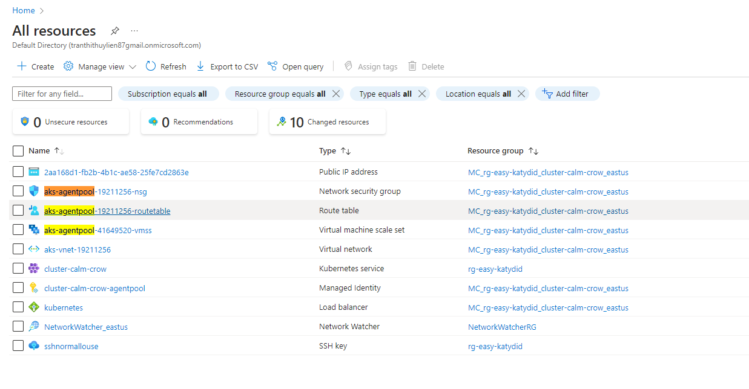
ACR
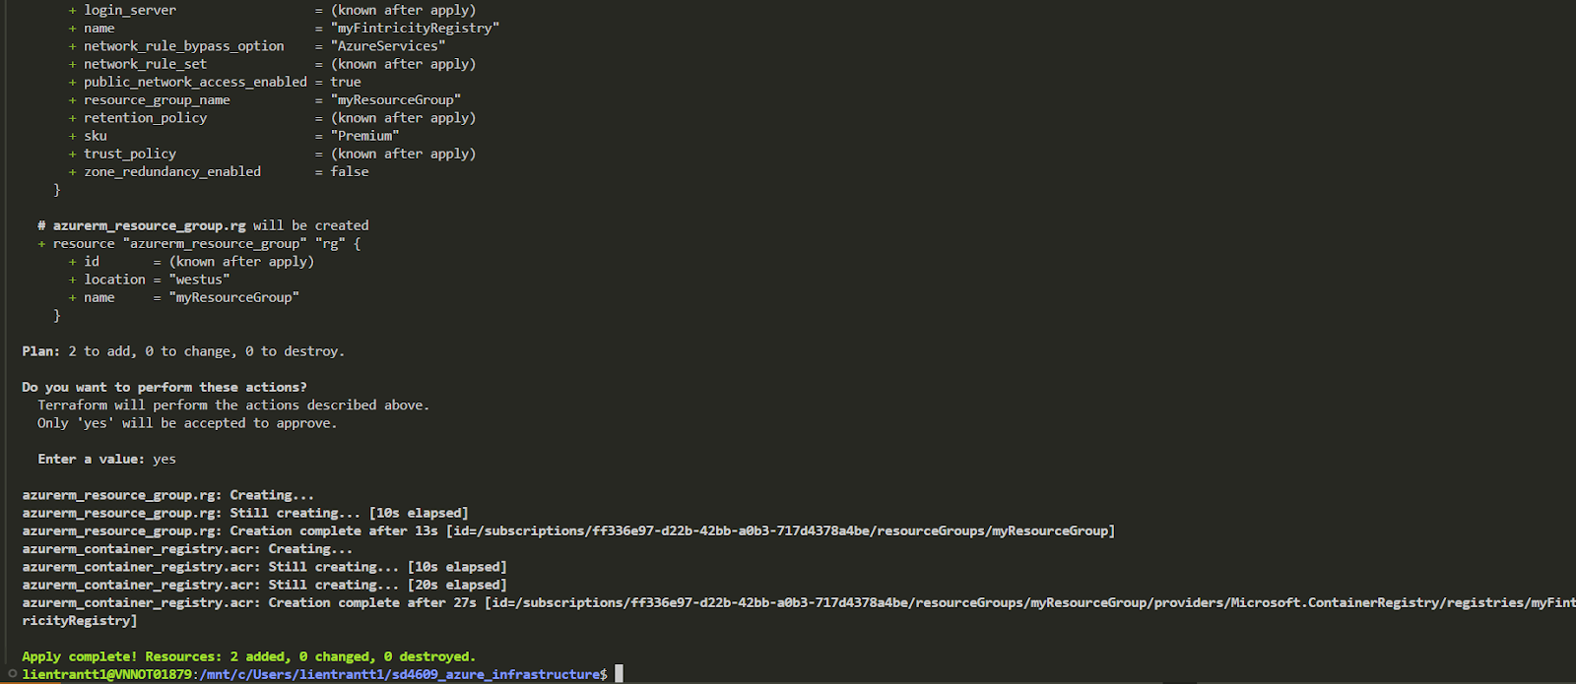

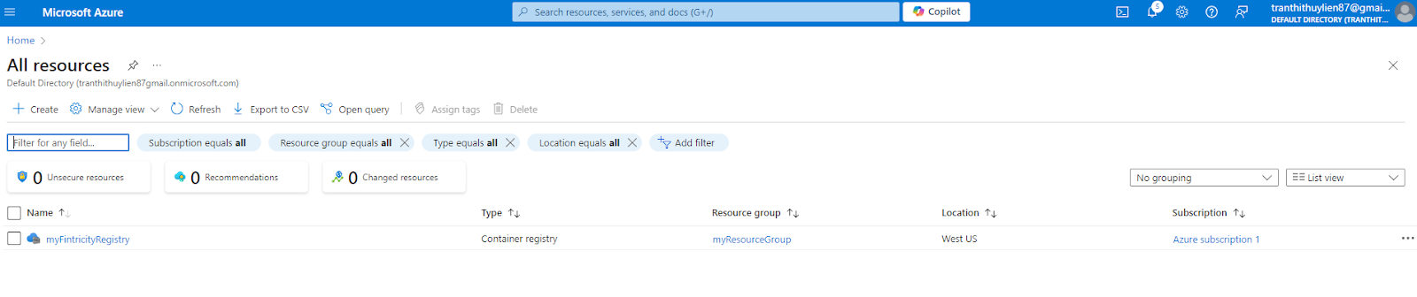

Pipeline Docker

